LAB No. 9
Convolution Neural Network
Open Ended LAB
Build a Convolutional Neural Network (CNN) using Python and TensorFlow/Keras to classify images of Cats and Dogs.
Instructions:
- Collect or download a dataset containing:
  - 500 images of Cats
  - 500 images of Dogs
- Organize the dataset as:
dataset/
cats/
dogs/
- Write Python code to:
- Load and preprocess images (resize to 150×150)
- Split into training (80%) and testing (20%)
- Build a CNN model
- Train the model for 10–20 epochs
- Plot training & validation accuracy and loss
- Evaluate model performance using a confusion matrix
- Predict whether a new input image is Cat or Dog
- At the end of the program, show the prediction result for a test image:
  - "This image is a CAT"
  - or
"This image is a DOG"
- Submit your Python code, dataset, graphs, and output screenshots.

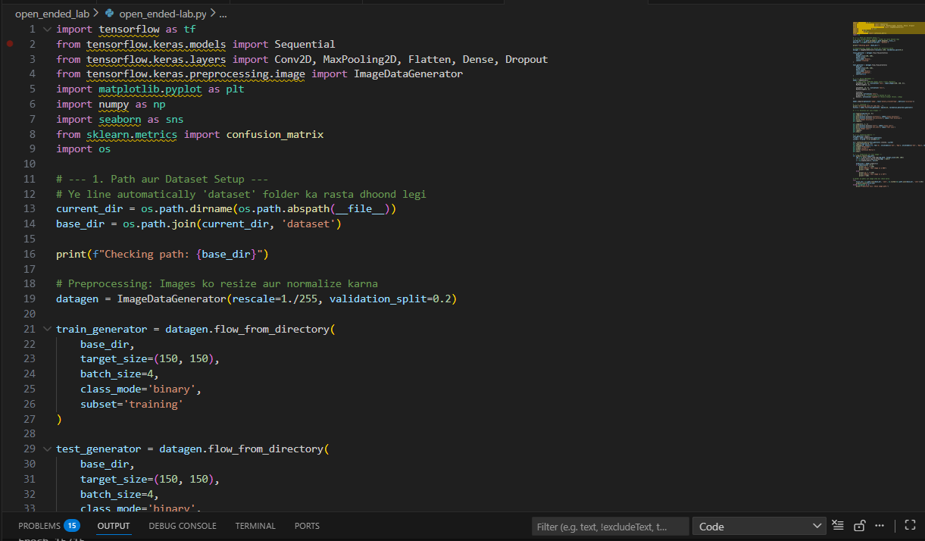
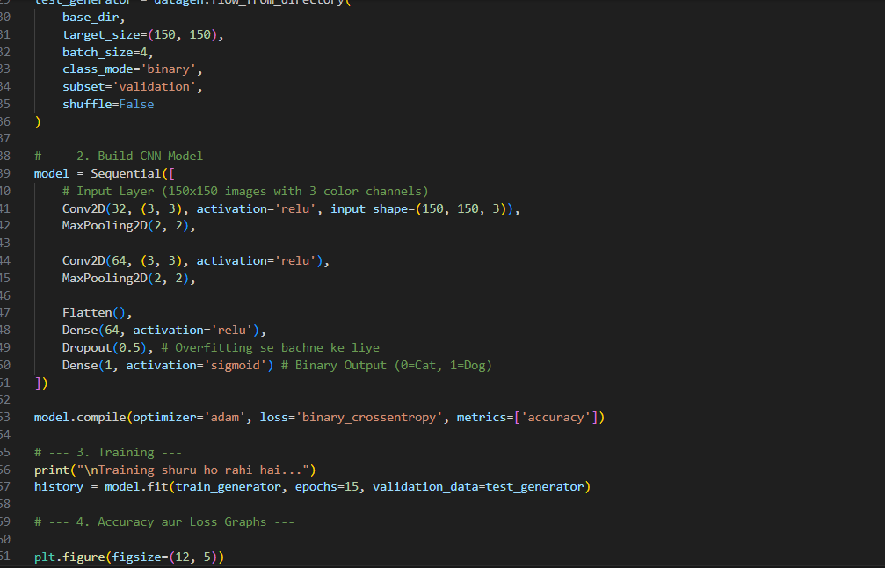
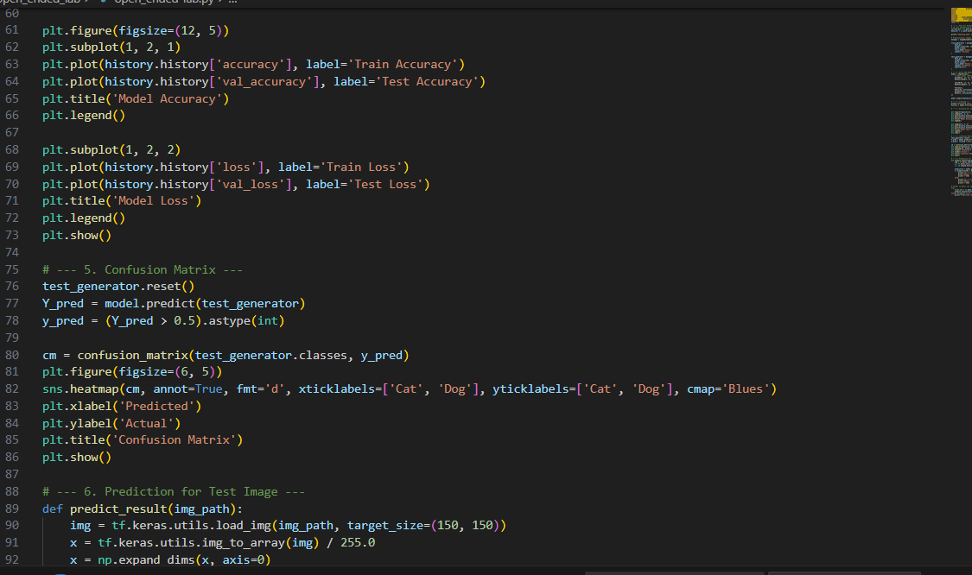
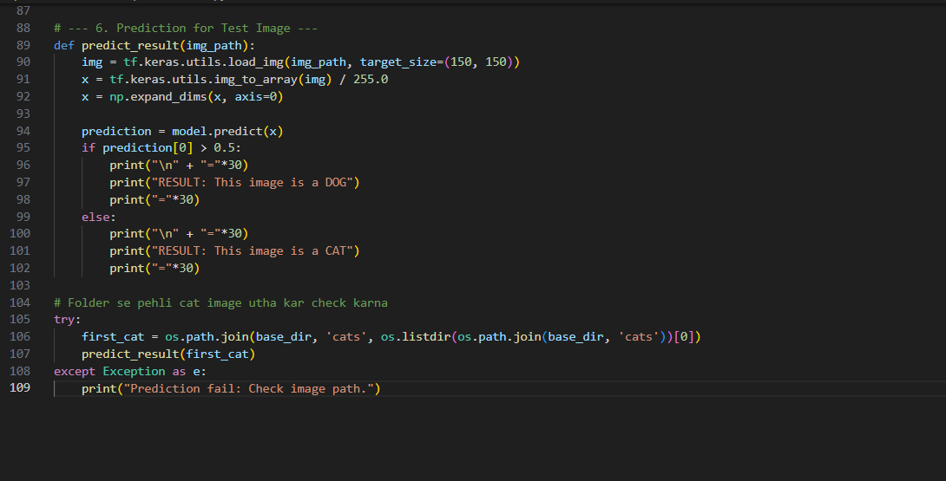
Graph
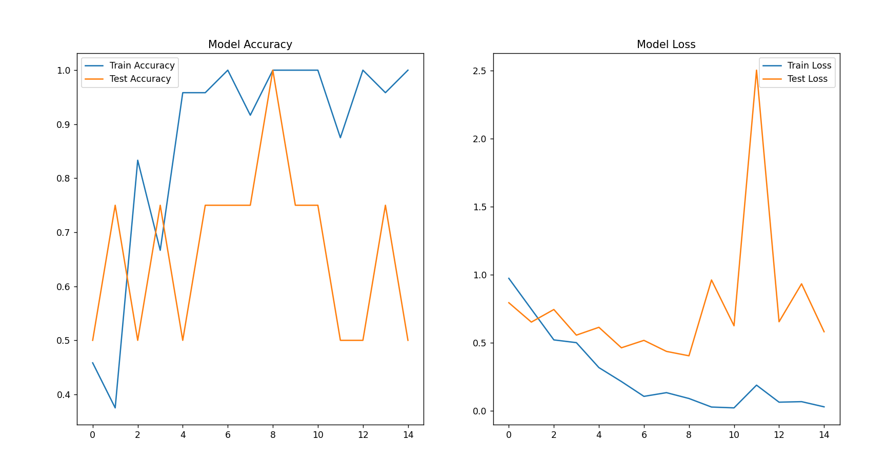
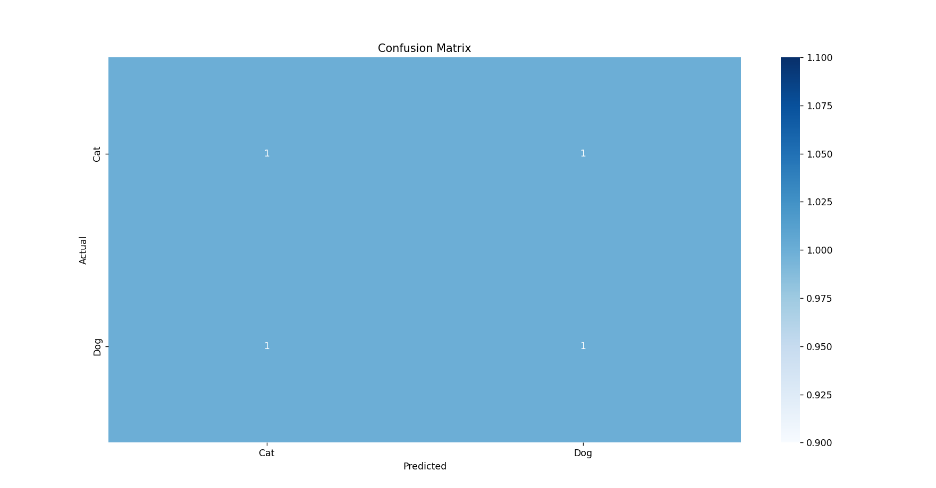

LAB Assessment

Student Name |  | LAB Rubrics | CLO3 , P5, PLO5
Student Name |  | Total Marks | 10
Registration No |  | Obtained Marks
Registration No |  | Teacher Name | Dr. Syed M Hamedoon
Date |  | Signature

